Bahria University,

Karachi Campus



LAB EXPERIMENT NO.

5

LIST OF TASKS

|  |  |
| --- | --- |
| TASK NO | OBJECTIVE |
| 1 | Write an assembly program that Read and Print Hello world. |
| 2 | Write an assembly program that add two numbers. |
| 3 | Write an assembly program that subtract two numbers. |

Submitted On:

22/10/19

(Date: DD/MM/YY)

**TASK NO.1:** Write an assembly program that Read and Print Hello world.

**SOLUTION:**

CODE:

**.data**

String: .ascii "Hello World"

**.text**

li $v0,4

la $a0,String

syscall

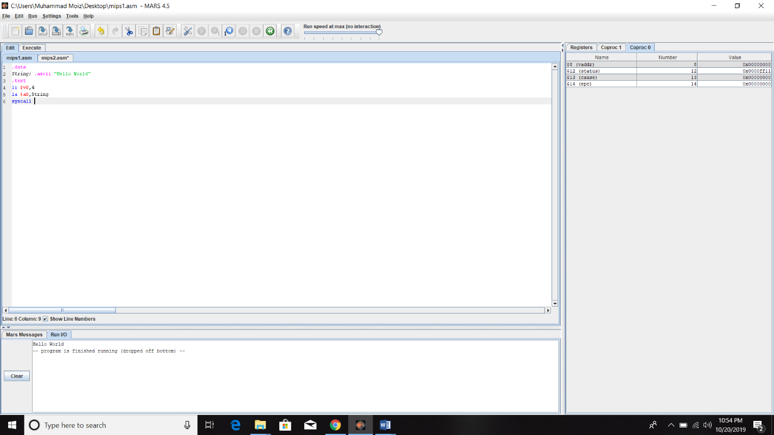OUTPUT:

**TASK NO.2:** Write an assembly program that add two numbers.

**SOLUTION:**

CODE:

**.data**

num1: .word 20

num2: .word 13

**.text**

lw $t0,num1

lw $t1,num2

add $t2,$t0,$t1

move $a0,$t2

li $v0,1

syscall

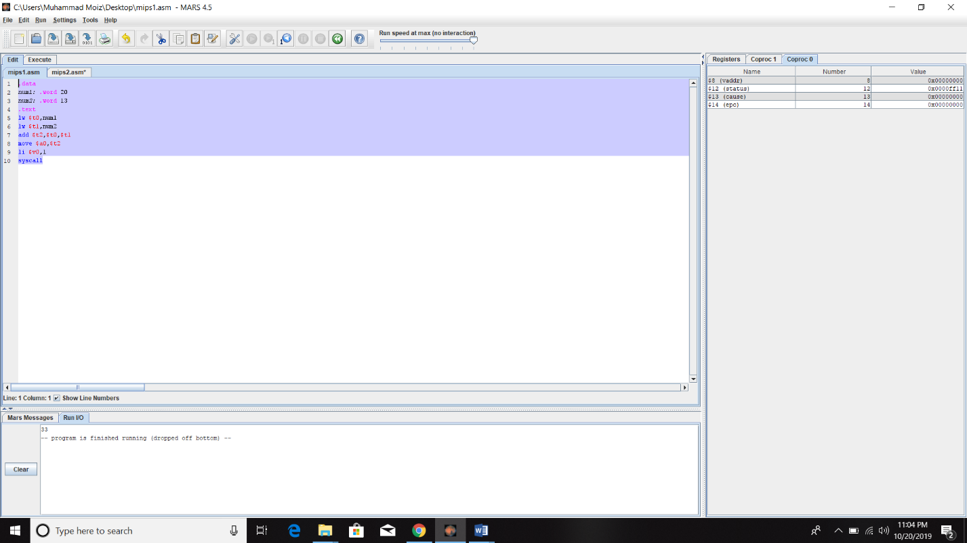OUTPUT:

**TASK NO.3:** Write an assembly program that subtract two numbers.

**SOLUTION:**

CODE:

**.data**

num1: .word 20

num2: .word 13

**.text**

lw $t0,num1

lw $t1,num2

sub $t2,$t0,$t1

move $a0,$t2

li $v0,1

syscall

OUTPUT:

